Report:

Title: Torsion of a Circular Shaft

1. **Objective**
2. For an aluminum circular shaft, we aim to obtain torque-twist relationship and compare the result with theoretical predictions.
3. **Experimental Method(s):**
4. The experimental setup included various instruments and sensors such as a torsion setup, a solid circular aluminium rod, an optical encoder, a vernier caliper, spacers, ruler, and marker pens.
5. The diameter and gauge length of the circular aluminium rod were measured, and a straight line was drawn on the rod before mounting it on the torsion setup using spacers.
6. The angle of twist was measured using an optical encoder.
7. The rod was then rotated in the torsion setup, and the data for torque vs twist angle was recorded until the rod failed.
8. To facilitate better visualization of the results, a graph plotting the torque vs twist angle could be generated.
9. **Results and Calculations:**

By measurements,

* Gauge Length (L) =100 mm
* Diameter of the shaft (d) = 9.7 mm
* Maximum observed angle of twist θ = 715.04˚

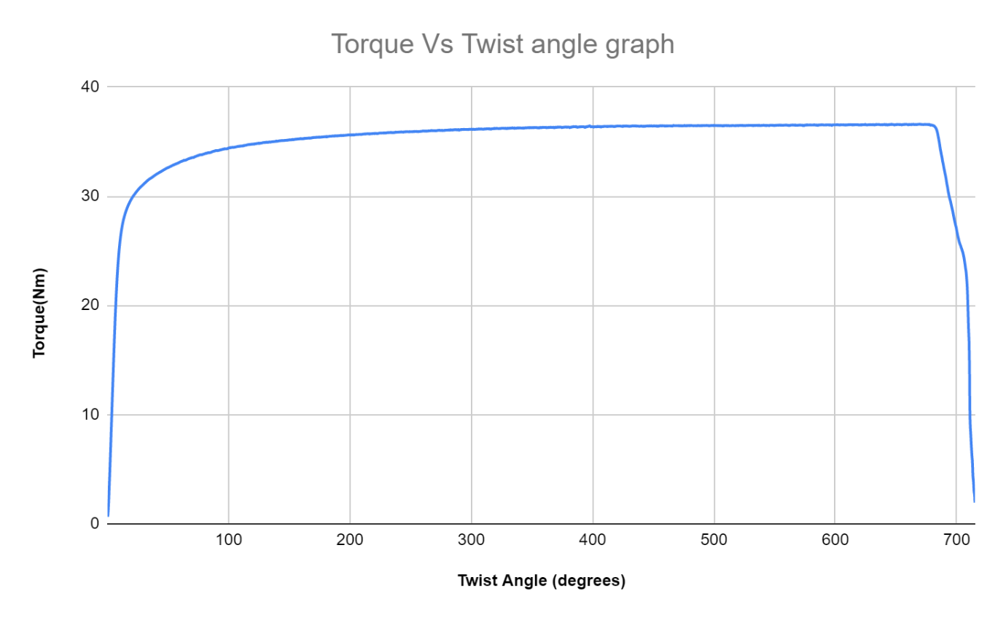

**Calculation:**

From the graph we have, Torque at which the linear region ends = **28.64 Nm**

Torque in the flat region of the curve = **36.58Nm**



Calculation of G needs to be done in the initial linear region of the curve,

At θ = 7.07821˚ = 0.1235 radian, T= 20.2655 Nm

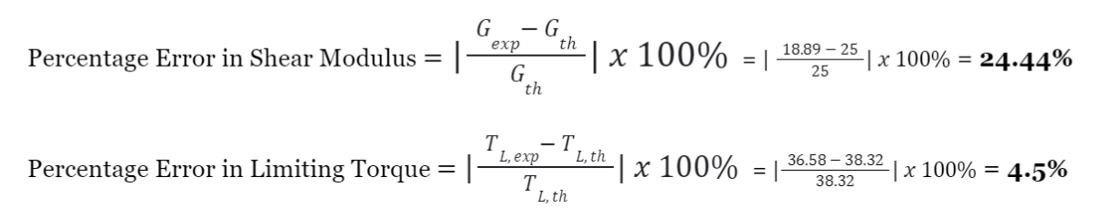Theoretical Shear Modulus of Aluminium (Gth) = **25 GPa**

**Results:**

1. Yield Torque **TY = 28.64 Nm**
2. Limiting Torque **TL, exp** = **36.58 Nm**
3. Maximum Torque Experienced **Tmax = 38.32 Nm**
4. Shear Modulus **Gexp =18.89 GPa**
5. % Error in Calculation of Shear Modulus = **24.44 %**.
6. % Error in Calculation of Limiting Torque = **4.5 %**
7. **Analysis/observations/discussion**
8. The rod breaks at the area having the highest stress concentration, which is why it usually breaks near the clamps.
9. The initial region is linear till the yield stress since we need to increase torque to increase twist angle
10. Once plastic deformation starts, the twist angle increases for small increases in torque until the point of limiting torque. Beyond this point the rod is broken and hence there is no need of torque
11. The Percentage error in Limiting Torque = 4.5%
12. The Percentage error in Shear Modulus of aluminium = 24.44%
13. **Summary/conclusions.**
14. Through our analysis, we discovered that the point of maximum stress concentration led to the breakage of the rod, which could occur at any point, typically near the clamps, based on the material's composition.
15. Upon examination of the rod, we found that it broke at a minimal twist angle, prompting us to investigate the cause. Ultimately, we determined that the rod's formation had resulted in cracks, causing it to fracture prematurely.
16. Our objectives were successfully met, as we were able to determine the limiting torque with an error of only 4.5%, which falls within the reasonable range of less than 10% and could be attributed to manufacturing defects. Additionally, we qualitatively achieved the experiment's aim.
17. We observed that initially, the torque and twist angle had a linear relationship until the yield point, after which the slope flattened significantly, with small increases in torque corresponding to more significant increases in the twist angle.
18. Following the point of the limiting torque, the torque decreased steeply, forming an almost straight line with minimal increases in the twist angle.
19. **Source of Error**:
    1. Insufficiently tightened screws could result in inaccuracies in the angle of twist, leading to measurement errors.
    2. To ensure accurate readings, it is important to use a shaft with a diameter and size that is compatible with the machine. Otherwise, errors in measurement may occur.